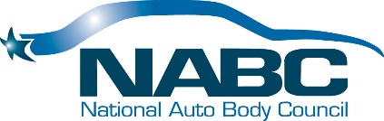
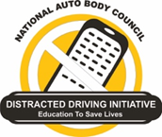
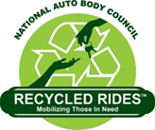

President’s Report:
Princeton, NJ
August 15, 2019

Update since Dallas:
All committees are working cohesively and make progress…it is exciting to see the fruits of their efforts
Highlight Reel:
- Rhythm and flow to our business
- Continuity
- Continuous Improvement
- Growing Membership Footprint
- Fiscal Strength
- Branding
- Website & Calendar still a WIP
- NABC DDI
- NABC F.R.E.E.™
- NABC Recycled Rides™ moved to a ®
- Membership
- Fundraising
- Governance Committee Updated Bylaws
- Awards Committee is the only committee I am not involved in….curious why that is
- Committee Leadership moving forward is strong and consistent with some voids
- Staff is committed

External sources are running efficiently:
- Victory Management Group 1 – 5 Scale: 6
- Chicago Law Partners 1 – 5 Scale: 5
- Association Executives Group 1 – 5 Scale: 1
- Katie Pharr -SME 1 – 5 Scale: 6
New Business:
- SEMA Task Force
- Elections & Annual Meeting
- Palm Springs 2019
- 2020 25th Anniversary

