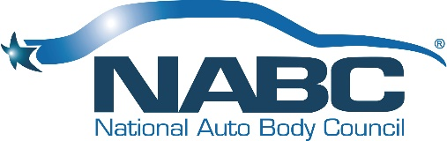
NABC® Marketing Committee Charter
Updated 1.31.22

Purpose:
To organize and promote vehicle giftings to qualified recipients while ensuring we hold true to the NABC® mission -- “improving the image of all dedicated collision industry partners” through the changing of each life benefitted by our giftings.

Budget:
The committee’s budget will be established each year by the fourth quarter for the upcoming fiscal year. Furthermore, monthly financial reports will be generated to monitor strategic goals vs. budget.

Deliverables:
The committee will produce quantifiable goals in the fourth quarter of each year for the upcoming fiscal year. The committee will report on progress versus goals every month during committee meetings and will provide periodic updates at Board Meetings. The committee will also prepare an annual review of prior year objectives at the January Board Meeting.

Scope and Risks:
The committee will hold true to all of NABC® policies and procedures to ensure all components of each gifting are vetted and adhere to NABC® high standards.

Timeframe and Milestones:
The committee will be evaluated by their ability to meet and deliver upon annual quantifiable goals as established by the committee and approved by the Board.

Key Stakeholders:
Board, President, Chair and or Co-Chairs of the committee, the committee members and the resources of our various partners, agencies and recipients.

Team Roles and Responsibilities:
- Chair or Co-Chairs will be responsible for leading the committee. Ensuring annual goals are established and achieved while adhering to all aspects of the committee’s charter
- Program Director will be responsible for administering all day to day aspects of the program
- Insurance Subcommittee Chair will lead all efforts associated with maintaining and increasing vehicle donations from carriers
- NABC Recycled Rides® for Schools Subcommittee Chair will lead the day to day

