Policies of the National Auto Body Council®

Board of Directors Attendance Policy

Purpose: This policy is intended to support full contribution of all board members; therefore all board members will receive a copy of this revised board policy. The policy is to be reviewed once a year by the Governance committee. The policy has been reviewed and authorized by the board (see signature and date below).

Definition of a Board Attendance Violation: A violation of the Board Attendance policy exists with any of the following conditions:
- The member has more than one absence in a calendar year
- The member has two consecutive absences during November and January
- Frequent tardiness or early departure of multiple board meetings

Response to a Board Attendance Violation: If a board attendance violation exists, the Chairman of the Board and Executive Director will contact the board member in order to obtain the reason(s) for the attendance violation. The Chair and Executive Director will then inform the Board member in question that their recommendations will be presented to the Executive Committee at which time the said Board member may also present their position. A vote will take place amongst the Executive Committee of whether or not said board member should remain on the Board of Directors. If a Board member is removed, the termination will be conducted per the following policy:

- The Board Chair will notify the terminated Board member in writing
- This written notification will request the Board member provide a letter of resignation to the Board of Directors within two weeks
- Any vacancies thereby created by a violation of the board policy and terminated board member shall be filled in the same manner as provided in the bylaws

Date_October 30, 2018________ (Board Policy Last Revised)

Standing Committees and Task Forces

The Chair and/or Board of Directors may create such standing committees and task forces as are necessary for the work of the Organization. The Chair shall appoint these workgroups with the approval of the Board of Directors. A standing committee is defined as having a long-term ongoing responsibility. A task force is a time-limited assignment and may be disbanded at the conclusion of its assigned task or at any time as determined by the Board of Directors. For any committee or task force, the Board shall approve a written charge or charter that shall include an expiration date or review date for their work.

Conflict of Interest

The Directors, contractors and committee members (“Parties”) of the National Auto Body Council® (NABC) shall avoid any conflict between their personal, professional, or business interests and the interests of the NABC™, in any and all actions taken on behalf of the NABC™ in the Parties’ respective capacities.

In the event that any of the Parties shall have any direct or indirect interest in or relationship with any individual or organization which proposes to enter into any transaction with the NABC including but not limited to transactions involving:

a. The sale, purchase, lease or rental of any property or other asset;
b. Employment or rendition of services;
c. The award of any grant, contract, or subcontract;
d. The investment or deposit of any funds;

Such person shall give notice of such interest or relationship and shall thereafter refrain from voting on the particular transaction in which he/she has an interest, or otherwise attempting to exert any influence on the NABC™ to affect a decision to participate or not participate in such transaction.

Code of Ethical Standards

The National Auto Body Council® Board members must be responsible for maintaining ethical behavior in relation to their work for the Council. Members may be in possession of sensitive information while engaging in business related activities such as reaching out to prospects, working with the Committees and members, fundraising and monitoring donations.

The National Auto Body Council® Code of Ethical Standards provides guidance to Board members as they complete their work for the Council. Violation of the standards may subject the member to disciplinary sanctions by the National Auto Body Council® Board.

Members shall:

- Protect the confidentiality of all privileged information.
- Effectively disclose all potential and actual conflicts of interest; such disclosure does not preclude or imply ethical impropriety.
- Not exploit any relationship with a donor or prospect for the benefit of the member or the member’s organization.
- Ensure that all solicitation and communication materials are accurate and correctly reflect the organization’s mission and use of solicited funds.
- Adhere to the principle that all donor and prospect information created by, or on behalf of National Auto Body Council® is the property of National Auto Body Council®.

I agree to this code of ethics.

_________________________________ ___________________________
(Name) (Date)

National Auto Body Council® Assets and Investment Policies

I. NABC™’s cash assets are apportioned as follows:

(A) Operating funds (from such revenue sources as membership dues, fundraising receipts, etc.) provide a pool of assets to support NABC™’s management and services. The NABC™ Treasurer Executive Director and Finance Committee shall determine the distribution of operating funds, preferring interest-bearing accounts and arranging for any necessary transfers of funds into the active checking account. The Finance Committee shall determine, after the close of each fiscal year, the asset allocation of any year-end surplus net income (e.g. leaving all net income in Operating funds; an apportionment between the Operating funds and the Reserve Fund; a crediting to the Speakers Fund; etc.).

(B) Restricted Funds provide the basis for various NABC™ grants, special events, new initiatives, awards, and honoraria.

(C) The Reserve Fund ensures that adequate resources shall be available to bridge possible budget shortfalls and cover unexpected expenses. Unrestricted gifts to NABC™ are credited to the Reserve Fund. Any earnings from investment accounts are distributed among the Restricted and Reserve funds, as determined by the NABC™ Finance Committee.

II. Investment pools/goals

Since the three purposes vary in goals and investment time horizons, they have been considered in this policy as separate investment pools as illustrated below. In establishing the policies and procedures that follow, the concept of asset allocation is regarded as the primary component of investment planning that governs the National Auto Body Council®’s three investment pools. Preservation of capital is of the highest importance. Funds may be pooled for greatest investment efficacy.

Operating funds
Time horizon: 0-12 months
Through study and analysis of cash flow the NABC™ Finance Committee establishes a plan to combine liquidity with maximum yield for idle funds. This plan will be evaluated annually by the Treasurer and NABC™ Finance Committee. Checking, money market, and savings accounts may be combined with short term certificates of deposit with staggered maturity dates and other cash management systems to satisfy the need for higher yields, and appropriate liquidity.

Restricted funds
Time horizon: 1-2 years
These funds must be invested conservatively enough to protect the principal and accrue a guaranteed annual yield to meet specific obligations, yet aggressively enough to maintain the National Auto Body Council®’s ability to meet those obligations. Allowable investments: fixed income funds (bonds), and money market mutual funds.

Investment Objectives
The principal objectives of the National Auto Body Council®’s investment program shall be:

- Preservation of capital on an absolute basis.
- Generation of income to fulfill the mission of the National Auto Body Council®.
- Growth of asset value at a rate greater than inflation (as measured by the Consumer Price Index).

Achieving these objectives will require assuming a moderate level of risk, a long-term investment horizon and diversification among assets. The funds will be invested to maximize interest and dividend income consistent with a prudent level of risk.

Return Objectives
The National Auto Body Council®’s compound annual total return objective for the total portfolio is an absolute return, net after all expenses, of the Consumer Price Index (CPI) of the beginning of year asset value. Returns will be measured over a three year period.

Although investment objectives are long term, performance and activities of the investment fund manager is responsible to report on the various investments to the National Auto Body Council® Controller, Executive Director, Treasurer and Chairman at a minimum of a quarterly basis in addition to any scheduled meetings of the Finance Committee.

Reserve Fund
Time horizon: 3+ years
Allowable investments: fixed income funds (bonds), mutual funds (stock- and/or money market). **These funds can be placed into more aggressive funds seeking higher returns than noted within the Return Objectives Statement

III. Forbidden investment instruments

Small cap funds, junk bonds, commodities, derivatives, individual stocks and bonds. If mutual funds are chosen, preference will be given to those without loads or 12b-l fees.

IV. Investments Review

The Treasurer and NABC™ Finance Committee shall review the NABC™ investment profile in consultation with the Executive Director and the Executive Committee each time an investment matures, or as deemed necessary by the Finance Committee. In any case, such review shall take place at least once a year.
National Auto Body Council® Brand Names & Logo Usage Policy
The mission of the National Auto Body Council® (NABC) is to develop, implement and promote community-based initiatives that exemplify the professionalism and integrity of the collision repair industry.
The National Auto Body Council® encourages its members to use the National Auto Body Council® logo and its associated program logos to actively promote NABC™-sponsored programs and initiatives.
The following brand names and logos are the sole and exclusive property of the National Auto Body Council®:
- National Auto Body Council®  - NABC™ | 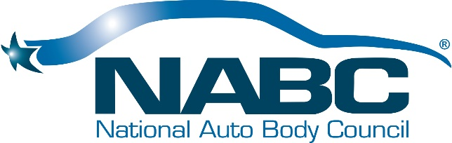
- National Auto Body Council Recycled Rides®  - NABC Recycled Rides® | 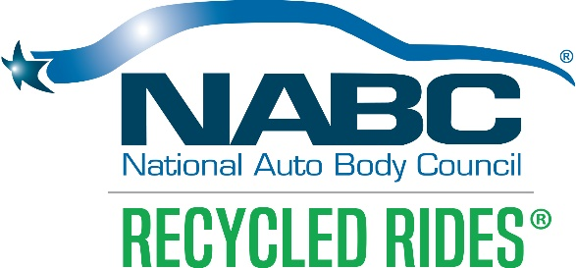
- National Auto Body Council First Responder Emergency Extrication™  - National Auto Body Council F.R.E.E.™  - NABC F.R.E.E.™ | 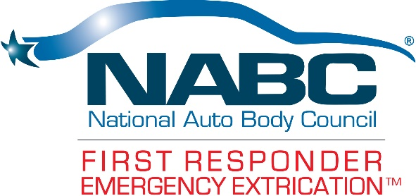
- National Auto Body Council Distracted Driving Initiative™  - NABC Distracted Driving Initiative™ | 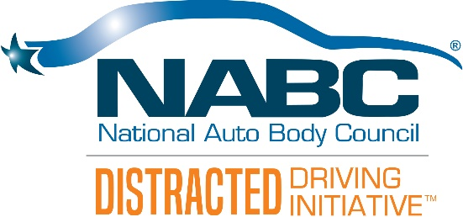
- National Auto Body Council® Award of Distinction  - NABC™ Award of Distinction | 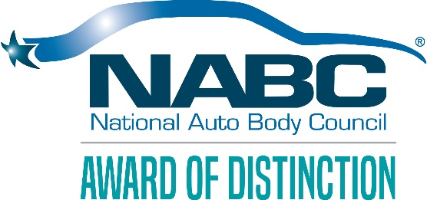
- National Auto Body Council® Body Shop Image Award  - NABC™ Body Shop Image Award | 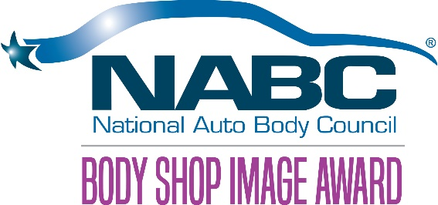

Who can use the National Auto Body Council® brand name and logos?
- Current members, in good standing with the National Auto Body Council®, can use and reproduce all of the above brand names and logos in conjunction with events, promotions, etc. that fulfill the NABC™ mission to develop, implement and promote community-based initiatives that exemplify the professionalism and integrity of the collision repair industry.
- Non-profit organizations participating in the National Auto Body Council Recycled Rides®, NABC F.R.E.E.TM, and NABC Distracted Driving Initiative™ programs are also free to use the above brand names and/or logos.

How can the National Auto Body Council® brand name and associated program logos be used?
National Auto Body Council® brand names and logos may be used in a professional manner on program participant business cards, stationery, literature, advertisements, collateral, announcements, banners, web site, etc. as long as the participating organizations adhere to brand name and logo usage guidelines outlined below.

National Auto Body Council® Logo Usage Guidelines
The registered trademark ® or ™ must be used for the NABC program names as outlined above
Please observe all the following guidelines when using the logos:
- Use only the approved digital artwork.
- Never change fonts on the logos.
- Never reproduce the logo in colors other than black/white and the approved PMS colors specified for each logo.
- Never outline the logo.
- Never distort the logo. Always scale it proportionately.
- Never place any graphics in or around the logo that could be interpreted as part of the logo.
- Any time the term Recycled Rides is used the registration mark “®” must be used appropriately and NABC or National Auto Body Council must proceed the term
- Anytime the term F.R.E.E. or Distracted Driving Initiative is used the trademark logo “TM” must be used appropriately and NABC or National Auto Body Council must proceed the term
- When logos are used in reference to NABC F.R.E.E.™, NABC Distracted Driving Initiative™ or NABC Recycled Rides®, the NABC logos must be used as well with proportionate size to another logo(s) in/on the piece
The logos may NOT be used in any of the following ways:
- Altered, revised, combined or merged with any other logos or graphic elements.
- On any product or items for sale, such as T-shirts, mugs, golf balls, etc., without the express, written consent of the National Auto Body Council®
- In any manner that, in the sole discretion of the National Auto Body Council®, discredits the organization and/or its programs and initiatives or tarnishes its reputation and goodwill.
- Is false or misleading
- Violates the rights of others
- Violates any law, regulations, or other public policy
- Mischaracterizes the relationship between the National Auto Body Council® and the user to construe endorsement, approval, sponsorship, or certification by the National Auto Body Council® of the user's business or organization, or the user's products or services
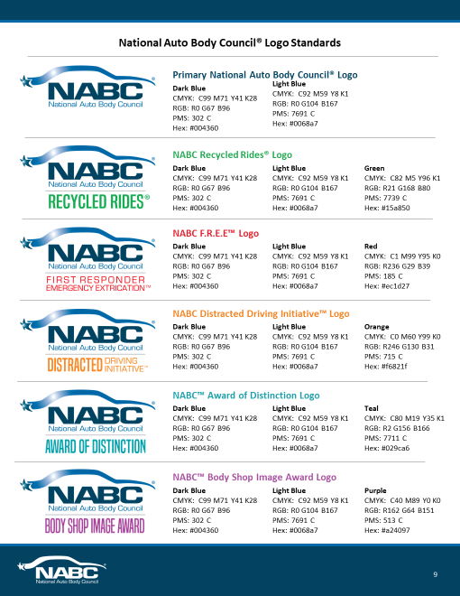

Where can I find the National Auto Body Council® logos?
Please request a copy of all Brand Standards from the National Auto Body Council® Public Relations/Marketing agency – Victory Management Group at: 312.505.4336 or email Deborah Robinson at drobinson@vmg1.com

Compliance
The logos shall remain at all times the sole and exclusive intellectual property of the National Auto Body Council®.
The National Auto Body Council® shall have the right to request samples of use of the logo from which it may determine compliance with the above logo guidelines.
The National Auto Body Council® reserves the right, at its sole discretion, to modify these logo usage guidelines at any time and to take appropriate action against any use without permission or any use that does not conform to these requirements.
The National Auto Body Council® shall be held harmless for any claim resulting through the improper display or usage of its logos by members, sponsors, non-profits, etc.

Whistleblower Policy

Reporting Responsibility
It is the responsibility of all directors, officers and employees of the National Auto Body Council® (the Organization) to comply and to report violations or suspected violations in accordance with this Whistleblower Policy.

No Retaliation
No director, officer or employee who in good faith reports a violation of the Policy shall suffer harassment, retaliation or adverse employment consequence. A director, officer or employee who retaliates against someone who has reported a violation in good faith is subject to discipline up to and including termination of employment and/or removal from board. This Whistleblower Policy is intended to encourage and enable concerns within the Organization to be raised prior to seeking resolution outside the Organization.

Reporting Violations
This policy addresses the Organization's open door approach and requires that directors, officers and employees share their questions, concerns, suggestions or complaints so they may be addressed properly. In most cases, the Compliance Officer is in the best position to address an area of concern. However, if you are not comfortable speaking with the Compliance Officer or you are not satisfied with their response, you are encouraged to speak with someone on the Executive Committee or the Executive Director. Should such concern involve the Chair of the organization, such notification must be reported to the Executive director.

Compliance Officer
The Chairman shall appoint a Compliance Officer with the approval of the board of the directors. The Compliance Officer is responsible for investigating and resolving all reported complaints and allegations concerning violations, and shall advise the Board of Directors. The Compliance Officer has direct access to the Board of Directors and is required to report to the Board of Directors at least annually on compliance activity as needed.

Accounting and Auditing Matters
All reported concerns or complaints regarding the Organization’s accounting practices, internal controls or auditing shall also be reported to the Compliance Officer who shall immediately investigate and notify the Board of Directors of any such complaint.

Acting in Good Faith
Anyone filing a complaint concerning a violation or suspected violation must be acting in good faith and have reasonable grounds for believing the information disclosed indicates a violation of policy has taken place. Any allegations that prove not to be substantiated and which prove to have been made maliciously or knowingly to be false will be viewed as a serious disciplinary offense which could include removal as a Director or termination if an employee.

Confidentiality
Violations or suspected violations may be submitted to the Compliance Officer on a confidential basis by the complainant. Reports of violations or suspected violations will be kept confidential to the extent possible, consistent with the need to conduct an adequate investigation.

Handling of Reported Violations
The Compliance Officer will notify the complainant and acknowledge receipt of the reported violation or suspected violation within five business days. All reports will be promptly investigated, and appropriate corrective action will be taken if warranted by the results of the investigation.

