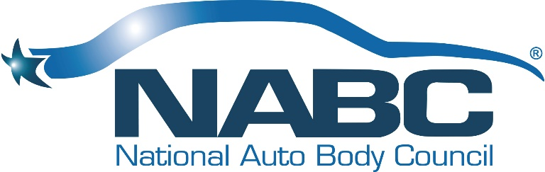

NATIONAL AUTO BODY COUNCIL
Board of Directors CLOSED Online Board Meeting
Wednesday, May 6, 2020 - 1:00 PM - 5:00 PM CDT

Our Vision
Automotive Collision Repairers are Admired Professionals

Our Mission
To develop, implement and promote community-based initiatives that exemplify the professionalism and integrity of the Collision Repair Industry

BOARD MEETING MINUTES

1:00 PM – 1:45 PM
- Welcome, Roll Call, Introductions & Anti-Trust Statement – Darren Huggins
  - Please see attached attendance report for BOD Members
- Approval of BOD Meeting Minutes January 13, 2020 – Doug Schlueter
  - Motion to Approve as presented and Seconded – Approved Unanimously
- Chairman’s Views and Perspective - Darren Huggins
- President’s Report & Comments – Bill Garoutte
- Treasurer’s Report – Brian Driehorst & Bill Garoutte

1:45 PM – 2:40 PM
Membership Report – Arlo Johnson, Anthony Natale and Katie Pharr

Committee Presentations – Liz Stein & Committee Co-Chairs
- NABC Distracted Driving Initiative™ -- Gene Lopez, Kristle Bollans, Matt Immerfall
- NABC F.R.E.E.TM – George Avery
- NABC Recycled Rides® -- Doug Schlueter, Linda Sulkala
- NABC Recycled Rides® 4 Schools – Doug Schlueter, Linda Sulkala

Break: 15 minutes

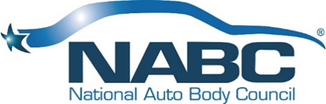

2:50 PM – 3:55 PM
Committee Presentations – Clint Marlow & Committee Co-Chairs
- Awards – Kevin Creegan, Clint Marlow
- Fundraising – Gerry Poirier and Liz Stein
- Governance – Stacy Bartnik, Chuck Sulkala
- Marketing – Kristle Bollans, Debbie Teter, Matt Immerfall

3:55 PM – 4:10 PM
- Old Business – Membership Matrix/Agreements
- New Business – Elections and Committee Leadership
- Now/Next/New Normal
- Open Board Meeting Adjournment

