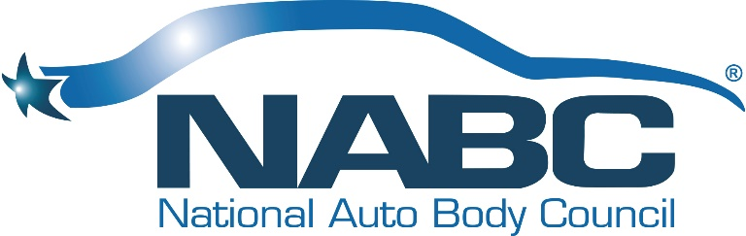

NATIONAL AUTO BODY COUNCIL
Board of Directors Events
Monday, January 13, 2020 - 12:00 PM-7:00PM PT
Hilton Palm Springs - Horizon 1
Palm Springs, CA

Our Vision
Automotive Collision Repairers are Admired Professionals

Our Mission
To develop, implement and promote community-based initiatives that exemplify the professionalism and integrity of the Collision Repair Industry

BOARD MEETING MINUTES

OPEN SESSION
- Welcome, Introductions & Anti-Trust Statement were addressed by Darren Huggins
- Approval of BOD Meeting Minutes November 4, 2019 presented by Doug Schlueter – APPROVED Unanimously
- Approval of 2019 Annual Meeting Minutes November 6, 2019 presented by Doug Schlueter – It was determined that the Annual Meeting Minutes were not to be reviewed or approved until the next Annual Meeting in 2020
- Treasurer’s Report presented by Brian Driehorst and Bill Garoutte
  - This report was received from AEG the Friday before the Board Meeting and was unaudited. It was distributed during the course of the meeting
- Chairman’s Views and Perspective - Darren Huggins
- President’s Report & Comments – Bill Garoutte
  - 2020 Board Meetings were discussed and most specifically about the late summer Board Meeting. It was determined and Approved Unanimously that we would have our summer Board Meeting in conjunction with the St. Louis Golf Fundraiser the day following the golf event. Summer Board Meeting will be September 22, 2020 at Enterprise Corporate Headquarters in St. Louis.
- Planning Meeting Direction & Comments – Darren Huggins
Committee Presentations – Liz Stein & Committee Co-Chairs
- NABC Distracted Driving Initiative™
- NABC F.R.E.E.TM
- NABC Recycled Rides®
- NABC Recycled Rides® for Schools
Committee Presentations – Clint Marlow & Committee Co-Chairs
- Awards
- Fundraising
- Governance
- Marketing
- Membership
- Old Business
- New Business
- Open Board Meeting Adjournment

The Board of Directors went into an Executive Session following the adjournment of the Open Board Meeting

Following the Executive Session, the NABC Committees broke up into Planning Sessions for 2020

- NABC Distracted Driving Initiative™
- NABC F.R.E.E.TM
- NABC Recycled Rides®
- NABC Recycled Rides® for Schools
- Awards
- Finance
- Fundraising
- Governance
- Marketing
- Membership

