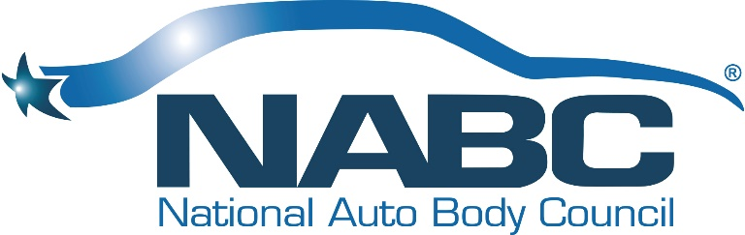

NATIONAL AUTO BODY COUNCIL
Board of Directors Events
Monday, January 13, 2020 - 12:00 PM-7:00PM PT
Hilton Palm Springs
Palm Springs, CA

Our Vision
Automotive Collision Repairers are Admired Professionals

Our Mission
To develop, implement and promote community-based initiatives that exemplify the professionalism and integrity of the Collision Repair Industry

New Board Member Orientation – Stacy Bartnik and Bill Garoutte
10:00-11:30 AM
Executive Board Room close to lobby and front desk

BOARD MEETING AGENDA

OPEN SESSION/ WORKING LUNCH
12:00 PM – 1:00 PM
Horizon 1 on Level 2
- Welcome, Introductions & Anti-Trust Statement – Darren Huggins
- Approval of BOD Meeting Minutes November 4, 2019 – Doug Schlueter
- Approval of 2019 Annual Meeting Minutes November 6, 2019 – Doug Schlueter
- Treasurer’s Report – Brian Driehorst
- Chairman’s Views and Perspective - Darren Huggins
- President’s Report & Comments – Bill Garoutte
- Planning Meeting Direction & Comments – Darren Huggins

1:00 PM – 2:15 PM
Committee Presentations – Liz Stein & Committee Co-Chairs
- NABC Distracted Driving Initiative™ (20 minutes)
- NABC F.R.E.E.TM (20 minutes)
- NABC Recycled Rides® (20 minutes)
- NABC Recycled Rides® 4 Schools (5 minutes)

Break: 15 minutes

2:30 PM – 3:45 PM
Committee Presentations – Clint Marlow & Committee Co-Chairs
- Awards (10 minutes)
- Fundraising (15 minutes)
- Governance (10 minutes)
- Marketing (20 minutes)
- Membership (15 minutes)

3:45 PM – 4:00 PM
- Old Business – Darren
- New Business – Darren
- Open Board Meeting Adjournment

- Board of Directors will go into a brief executive session following the break

Break: 15 minutes

NABC Committee Planning Sessions

4:15 PM – 6:15 PM PT
Hilton Palm Springs - Horizon 1
Palm Springs, CA

4:15 PM - 5:15 PM PT
- NABC Distracted Driving Initiative™
- NABC F.R.E.E.TM
- NABC Recycled Rides®
- NABC Recycled Rides® 4 Schools

5:15 PM – 6:15 PM PT
- Awards
- Finance
- Fundraising
- Governance
- Marketing
- Membership

