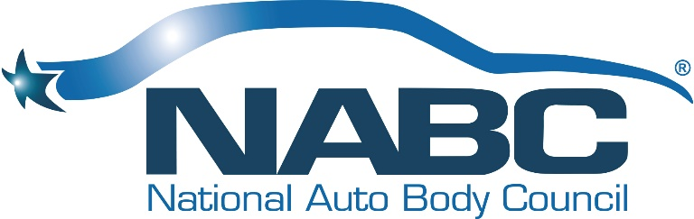

NATIONAL AUTO BODY COUNCIL
Board of Directors CLOSED Online Board Meeting
Wednesday, May 6, 2020 - 1:00 PM - 5:00 PM CDT
https://global.gotomeeting.com/join/547099629
You can also dial in using your phone.
United States: +1 (872) 240-3311
- One-touch: tel:+18722403311,,547099629#
Access Code: 547-099-629
New to GoToMeeting? Get the app now and be ready when your first meeting starts: https://global.gotomeeting.com/install/547099629

Our Vision
Automotive Collision Repairers are Admired Professionals

Our Mission
To develop, implement and promote community-based initiatives that exemplify the professionalism and integrity of the Collision Repair Industry

BOARD MEETING AGENDA

1:00 PM – 1:45 PM
- Welcome, Roll Call, Introductions & Anti-Trust Statement – Darren Huggins
- Approval of BOD Meeting Minutes January 13, 2020 – Doug Schlueter
- Chairman’s Views and Perspective - Darren Huggins
- President’s Report & Comments – Bill Garoutte
- Treasurer’s Report – Brian Driehorst & Bill Garoutte

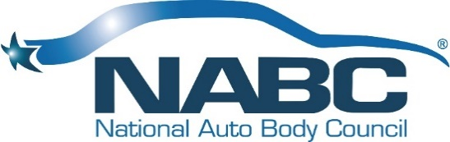

1:45 PM – 3:00 PM
Committee Presentations – Liz Stein & Committee Co-Chairs
- NABC Distracted Driving Initiative™
- NABC F.R.E.E.TM
- NABC Recycled Rides®
- NABC Recycled Rides® 4 Schools

Break: 15 minutes

3:15 PM – 4:30 PM
Committee Presentations – Clint Marlow & Committee Co-Chairs
- Awards
- Fundraising
- Governance
- Marketing
- Membership

4:30 PM – 5:00 PM
- Old Business – Darren
- New Business – Darren
- Now/Next/New Normal
- Open Board Meeting Adjournment

