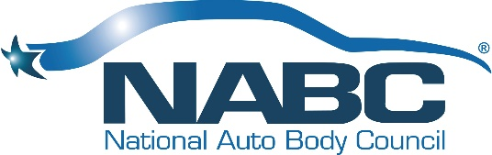
NATIONAL AUTO BODY COUNCIL
2019 Annual Meeting
Wednesday, November 6, 2019
3:00 PM – 5:00 PM

Westgate Las Vegas Resort & Casino
3000 Paradise Road, Conference Rooms 11 - 13
Las Vegas, NV 89109

2019 Annual Meeting Minutes
Attendance:
Katie Pharr
Guy Bargnes
Kerry Angers
Arlo Johnson
Kristle Bollans
Anthony Natale
Clint Marlow
Barry Barbee
Randy Wittig
Brian Driehorst
Matt Immerfall
Darren Huggins
Stacy Bartnik
Gerald Poirier
Linda Sulkala
Chuck Sulkala
Michael Jordan
Gene Lopez
George Avery
Keith Egan
Douglas Schlueter
Debbie Teter
Petra Schroeder
Kevin Creegan
Paul Grant
Paul Williams
Robin Roberson
Liz Stein
Domenic Brusco
Luke Harris
John Hollingsworth
Doug Webb
Eric Showalter
Sharlene Showalter - Guest
- Meeting was called to order by Mr. Garoutte
- Meeting followed the agenda that is attached.
- 2018 Annual Meeting Minutes were approved
- The vote on amending the original Articles or Organization did not occur as there was not 2/3rd’s of the membership in attendance. This will be done via an electronic vote to all members.
- Annual Board Elections:
  - It was noted by Mr. Garoutte that there were individuals in attendance that, based on their membership status, would have the opportunity to cast more than one vote per person per the NABC Bylaws. Motion was made and approved that all in attendance would only be allowed one vote per person.
  - The slate of candidates was presented as per the attached PowerPoint presentation
    - It was noted that Josh Byres had withdrawn his name for consideration this election
  - Ballots were distributed, cast and counted.
  - New Board Members Voted in are:
    - Paul Grant
    - Matt Immerfall
    - Clint Marlow
    - Anthony Natale
    - Doug Schlueter
    - Liz Stein
    - Debbie Teter
  - The new total Board is now:
    - Kerry Angers
    - Barry Barbee
    - Keith Bell
    - Kristle Bollans
    - Kevin Creegan
    - Brian Driehorst
    - Keith Egan
    - Paul Grant
    - Luke Harris
    - Darren Huggins
    - Matt Immerfall
    - Arlo Johnson
    - Michael Jordan
    - Gene Lopez
    - Clint Marlow
    - Anthony Natale
    - Gerry Poirier
    - Doug Schlueter
    - Liz Stein
    - Debbie Teter
    - Randy Wittig
  - The new board immediately moved to Executive Session and the following members were voted to serve on the Executive Committee:
    - Chairman Darren Huggins
    - Vice Chair-Industry Relations Clint Marlow
    - Vice Chair-Community Relations Liz Stein
    - Secretary Doug Schlueter
    - Treasurer Brian Driehorst
    - Director At Large Barry Barbee
    - Immediate Past Chair Domenic Brusco
  - The 2019 Annual Meeting was adjourned
  - A group picture of the new BOD was organized and taken

