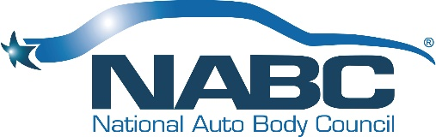
NABC Marketing Committee Charter
Updated 1.31.22

Purpose:
To serve as the brand ambassadors for the National Auto Body Council® in promotion and protection of the NABC® Brand(s). To support and further develop all programs and initiatives that deliver value to the brand, our member partner, and the industry. Participate in overall strategic direction, assess risks, and provide guidance in the areas of marketing and branding.

Budget:
The committee budget is established each year in the 3-4th quarter for the coming fiscal year and monthly financial reports will be generated to monitor strategic goals vs. budget.

Deliverables:
Through the marketing committees support we will deliver on a full list of priorities, tasks, budget and completion dates for the fiscal year while fully delivering on the committee’s purpose of supporting the overall organization of the NABC® and committees and programs.

Scope and Risks:
The Marketing Committee will have overarching responsibilities to each committee for brand standards and efficient and effective use of the marketing resources (human and financial).

Timeframe and Milestones:
The committee will be evaluated by their ability to meet and deliver upon expectations set by the Board, The President and our partner members in delivering value and an exceptional experience in participating with the NABC®.

Key Stakeholders:
Board, President, Chair and or Co-Chairs of the committee, the committee members and the resources of our various partners and agencies.

Team Roles and Responsibilities:
The committee will report to the President through the Chair(s) of the committee. The Chair(s) will recruit members to serve an active role and be responsible for budget, timeframes, and succession planning for the committee.

