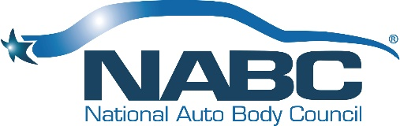
NABC® Fundraising Committee Charter
Updated 1.31.22

Purpose:
To serve as the fundraising support for the National Auto Body Council®. To develop and initiate fundraising events that promote professionalism, our mission and support the overall organizational programs.

Budget:
The committee budget is established each year in the 3-4th quarter for the coming fiscal year and monthly financial reports will be generated to monitor strategic goals vs. budget.

Deliverables:
Deliver and develop events that will increase awareness of NABC and its programs while promoting industry collaboration and support. Historical event data (playbook) to be established and used as a template for all events.

Scope and Risks:
The Fundraising Committee will have responsibilities to financially support the overall organization and its programs. If fundraising efforts are unsuccessful, the NABC® would be required to operate off funds through membership alone.

Timeframe and Milestones:
The committee will be evaluated by their ability to deliver profitability upon each event(s)and measured against pre-event goals. Scheduled meetings at a minimum of one a month are the expectations.

Key Stakeholders:
Board, President, Chair and or Co-Chairs of the committee, the committee members, partners and general membership.

Team Roles and Responsibilities:
The committee will report to the President through the Chair(s) of the committee. The Chair(s) will recruit members to serve an active role and be responsible for budget, timeframes, and succession planning for the committee. Each event will have a market champion to help lead the events efforts and help generate local support.

