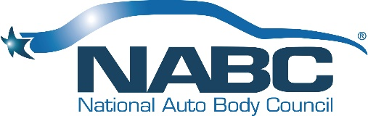
NABC First Responder Emergency Extrication Program (FREE™) Charter
As of 1.31.22

NABC F.R.E.E.™ Committee Purpose – The NABC F.R.E.E.™ program is a collaborative effort by collision repair facility, insurance companies that donate salvage vehicles and one of the NABC® rescue partners which provides expert instructors and equipment to facilitate the event.

Advances in technology have made today’s vehicles much safer for passengers but first responders often face challenges preventing further injuries to accident victims or themselves due to the complexities of the new technology.

The value of the NABC F.R.E.E.™ Program is to assist First Responders with knowing specifically where and how to efficiently cut and extricate can make the difference in saving precious minutes and lives as well as the safety of the first responders.
Duration and Time Commitment – NABC F.R.E.E.™ committee members have the opportunity to review the NABC F.R.E.E.™ Task List to determine what opportunities best fits the committee member’s skill sets and availability.

NABC F.R.E.E.™ committee members are asked to attend the monthly NABC F.R.E.E.™ committee conference call each month. The one-hour NABC F.R.E.E.™ Committee call is scheduled the third Thursday of each month at 1:00PM ET/12:00PM CT/10:00AM PT
Committee Members – The NABC F.R.E.E.™ committee chairperson is responsible for soliciting future committee members. In addition, anyone interested in joining the committee is welcome to contact the NABC F.R.E.E.™ committee chair, NABC F.R.E.E.™ program Manager or any of the current committee members.
Desired End Result – The primary goal of the NABC F.R.E.E.™ committee is to provide direction, address new ideas as well as concerns with the process provided to NABC® members.
Supporting Resources – The supporting resources include but are not limited to direction/guidance provided by Board of Directors, Vice-Chair of Community Involvement, and the CEO/President.
Reporting Plan – NABC F.R.E.E.™ committee performance and event status are provided at scheduled NABC® Board Meetings or by contacting the NABC F.R.E.E.™ program Manager.
Deliverables – Provide NABC® members with the opportunity to host a NABC F.R.E.E.™ event to give back to their community. Events range between 30 and 50 events a year.

NABC® members hosting a NABC F.R.E.E.™ event can expect multiple resources which include Instructors from HURST Jaws of Life or Genesis Rescue Systems, four late-model vehicles from their preferred insurance company, and all necessary forms and templates. Media Press Releases are also included.

